# Requirements & Initial Design

# Old Requirements

1. This object should be as compact as a normal desk lamp so it will not take up too much space on desks.
2. The lamp needs to be able to detect the time of day and adjust the temperature accordingly.
3. Display information in the LCD.
4. Have a focus mode to help with productivity. (For final design)
5. It needs to look pleasing on a desk. (For final design)
6. Needs to read the light level in the room.

# New Requirements

1. This object should be as compact as possible.
2. The lamp needs to be able to detect the time of day and adjust the temperature accordingly.
3. Display information on the LCD.
4. Look pleasing on the desk.
5. Integrate API functionality

# Design

 

The design has stayed basically the same. Using the API we were able to separate the bulb from the arduino, which would allow us to keep the design looking better being able to make the lamp look nice without having to figure out how to intigate the arduino with all its wires and sensors into the lamp or the light. Now the light bulb can be controled from anywhere aslong as there is an internet conection.

# Code Design

The functions that we need this device to be able to do are:

* Check and display the time onto the LCD
* Change the brightness of and colour of the Smart Blub.
* Communicate with he API

# Checking the Time

Since our code for checking the time worked so well in the last project we didn’t’ have to change anything about it.

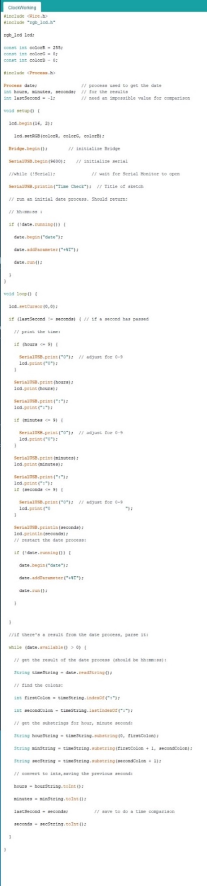

# Controlling the Smart Light

We found this code online That would allow us to communicate with the software designed to modify the temperature and colour settings of the smart light using the API If This Then That (ITTT).

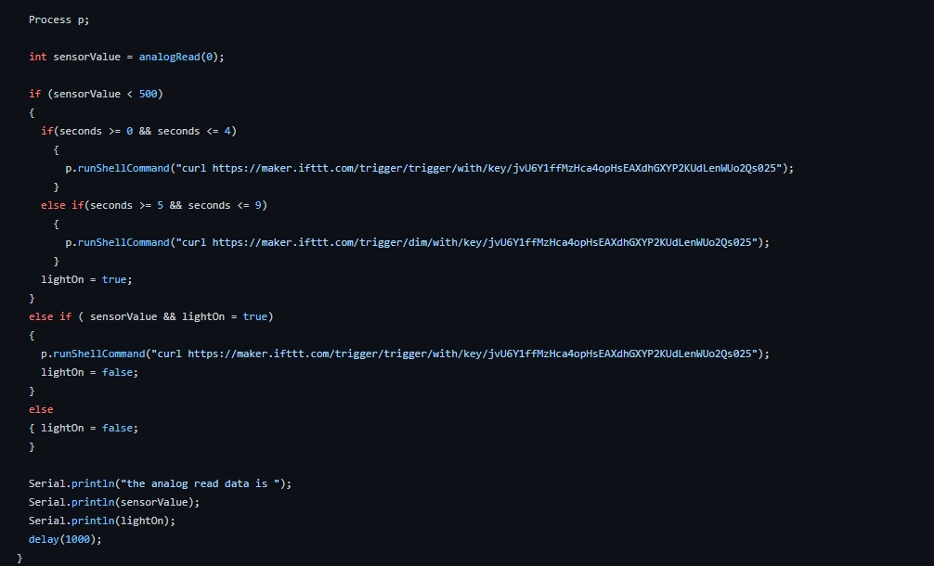

# hardware setup

The hardware we used for the projects was:

* Base Shield
* LCD RBG Backlight
* Philiphs Smart Light
* Light Sensor
* Wires

